The Simel’s Wedding Website Development

1. What’s the website’s main purpose?

Guidance on what the wedding is about

Guidance on gifting options

Guidance on nearby accommodation and transport options

Direction of the wedding venue

1. Which color do you want as the theme for the website?

White

Royal Green

Luminous Orange

Luminous Lemon

Luminous Red

Luminous Rose

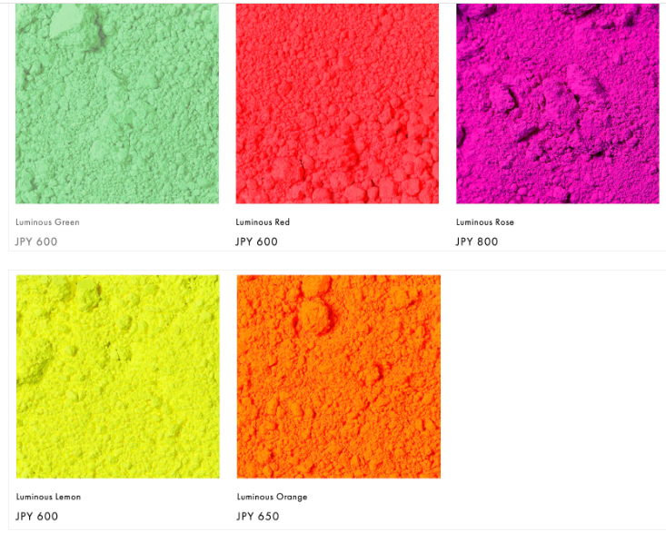

1. What do you want the website to do functionality? Eg: gift records.

Yes

1. Website content? “I can research others but please mention the main ones”

Please clarify

1. Is the website’s only audience the wedding guests? Yes Yes

Website Content

1. I want to have a section where, you tell the audience how you met?

Moses and Honour met in church after receiving an invite from Honour’s mum seven years ago. They became friends for six years and dared to have a date and as they say, the rest is history!

1. We could have a news section, giving updates about the wedding…

Yes, like additions of hotels, villas or air bnbs that could be paid for by guests, that are close to the wedding venue.

1. Wedding Date?

February 28th 2025

1. Email either yours or Moses’ and Phone Number incase someone has a question?

[honourgathoni@gmail.com](mailto:honourgathoni@gmail.com)

[mksimel75@gmail.com](mailto:mksimel75@gmail.com)

1. Another Section / Row would be the gift section. What do you want this gift record app to do?

Should anyone wish to gift us, kindly consider an enveloped gift.

Otherwise, the rest we can discuss on call.

**New Ideas:**

1. Photos of the wedding venue.
2. Date and Time clock counting down.

Final content for Website

* First section is for invitation message to wedding
* Second section is date and RSVP
* Final section is for location

First section